# Music Policy

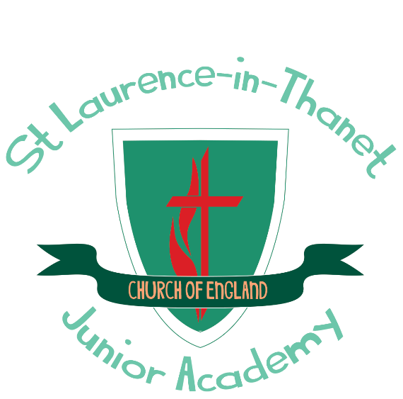

**Our school offers a supportive, inclusive, nurturing and inspiring learning environment where each member is known by God, loved and empowered to reach their full potential. Children are encouraged through an aspirational and engaging curriculum to develop their knowledge, skills and character so that they can truly flourish, both now and into the future.**

This set of values is reflected in all our policies.

Joy Hope Forgiveness Love Resilience

|  |  |  |
| --- | --- | --- |
| **Approved by:** | C Bottle | **Date:** April 2025 |
| **Last reviewed on:** | April 2025 | |
| **Next review due by:** | April 2027 | |

# St Laurence C of E Junior Academy Music Policy

**Introduction**

This policy outlines the purpose, nature and management of the Music taught and learnt in our school. It has been adopted by the staff of St Laurence C of E Junior Academy. This policy outlines the guiding principles by which this school will implement Music.

At St Laurence, we adopted the philosophy that “we are all musicians”. This means that everyone, children and staff, have the ability to play and express themselves through music and composition regardless of ability, that everyone is able to listen to and appraise music and openly discuss their likes and dislikes and have an understanding of the history of music.

# Rationale for Music teaching

Music is a powerful form of communication that allows children to explore their own thoughts, feelings and actions. It enables reflection, personal expression and emotional development. Music promotes children’s spiritual, moral, social and cultural development. The learning of music develops an awareness and appreciation of musical traditions, from the past and present and across a range of cultures. This helps children understand themselves and relate to others, forging important links between home, school, the local community and the wider world. Experiences of music should therefore be as many and as varied as possible. The teaching of music develops

children’s abilities to listen to and appreciate a wide range of music, and ensures that applying knowledge and understanding are developed through the interrelated skills of listening, appraising, performing and composing, giving children ample opportunity to make good progression in their skills over their school career.

# Aims for the teaching of Music at St Laurence C of E Junior Academy

At St Laurence the music curriculum enables pupils to develop:

* The capacity to express ideas, thought and feelings through music;
* An awareness and appreciation of organised sound patterns, understanding and exploring how music is created, produced and communicated, including through the inter-related dimensions: pitch, duration, dynamics, tempo, timbre, texture, structure and appropriate musical notations;
* Skills in movement, such as motor co-ordination and dexterity, vocal skills and skills in aural imagery;
* The experience of fulfilment which derives from striving for the highest possible artistic and technical standards;
* The ability to make sensitive, analytical and critical responses to music, along with an awareness and increasing understanding of traditions, idioms and musical styles from a variety of places, cultures and times through performing, listening to, reviewing and evaluating music across a range of historical periods, genres, styles and traditions, including the works of great composers and musicians;
* Skills in using their voices and learning a musical instrument, with the opportunity to progress to the next level of musical excellence;
* Skills in creating and composing music on their own and with others, including using technology appropriately;
* Social skills and awareness through making music together and performing to the school and in the wider community.

# All pupils should have the opportunity to:

* Listen to a wide variety of high-quality live and recorded music;
* Respond in a variety of forms reflecting their ability to use musical knowledge and language;
* Learn songs from different times and places using a varied repertoire of styles and cultures and perform as soloists, in groups or large ensembles, using material relevant to their age and musical development;
* Acquire musical skills and concepts which allow them to respond to a variety of stimuli in order to produce compositions and improvisations for different audiences and performers;
* Understand and apply the musical elements of pitch, duration, dynamics, tempo, timbre, and texture;
* Acquire musical skills which enable them to play classroom percussion instruments and other specific instruments according to current provision through Music Plus;
* Develop the ability to represent and record sounds using staff or other notation, and develop skills in using music technology to produce sounds and compositions;
* Develop improvisation and aural skills using the voice, body percussion and classroom instruments;
* Develop an understanding of musical terminology in order to communicate musical ideas to others.

# Music in relation to the National Curriculum

In line with the National Curriculum, Music teaching ensures that all pupils are taught to sing and play musically with increasing confidence and control. They are able to develop an understanding of musical composition, manipulating ideas within musical structures and reproducing sounds from aural memory. Music teaching ensures that all pupils:

* Play and perform in solo and ensemble contexts, using their voices and playing musical instruments with increasing accuracy, fluency, control and expression;
* Improvise and compose music for a range of purposes using the inter-related dimensions of music, with a progressive understanding of the musical elements of pitch, duration, dynamics, timbre, texture, tempo and their use within structure;
* Listen with attention to detail and recall sounds with increasing aural memory;
* Use and understand staff and other musical notations
* Appreciate and understand a wide range of high-quality live and recorded music drawn from different traditions and from great composers and musicians
* Develop an understanding of the history of music.

Teaching provides a balanced programme of activities which provides opportunities for pupils to work individually, in pairs, in groups and as a whole class, using ICT appropriately to support learning.

# Music curriculum planning

Music planning is based on the guidance set out in the National Curriculum and links to year group topics wherever possible with a focus on ensuring progression. Music is taught using a mastery approach using the Charanga Musical School Units of Work, which enable children to understand musical concepts through a repetition-based approach to learning. Learning about the same musical concept through different musical activities enables a more secure, deeper learning and mastery of musical skills.

# Management and Organisation

The Music Subject Leader is responsible for the teaching of music throughout the school. The role of the Music Subject Leader includes:

* Co-ordinating the implantation of the music policy
* Ensuring that Music lessons meet the aims and objectives of the Music curriculum and that each child receives his/her entitlement through a differentiated approach
* Ensuring that adequate resources are available and easily accessed and that there is a suitable variety of recorded music
* Monitoring and evaluating the teaching and learning of music throughout the school
* Attending relevant professional development courses
* Ensuring that at least one year group has opportunities for instrumental tuition to conform to Music Plus expectations. Follow-on opportunities for interested pupils will be provided where possible
* Organisation of instrumental teaching
* Provision of extra-curricular activities for the continuation of music, such as Band, Recorder Club and Choir
* Organisation of opportunities for pupils to perform both at school and in the wider community, and for pupils to experience live music presentations and performances both within and outside the school

# Spiritual, Moral, Social and Cultural Development

Children are provided with many opportunities for listening, during worship times and in lesson times, which gives them time to reflect. The teaching of Music offers opportunities to support the social development of our children through the way they are expected to work with each other in lessons. Groupings allow children to work together, and give them the chance to discuss their ideas and feelings about their own work and the work of others. Through their collaborative and co- operative work across a range of activities and experiences in music, the children develop respect for the abilities of other children and a better understanding of themselves. They also develop a respect for the environment and for that of others. They develop their cultural awareness and understanding, and they learn to appreciate the value of differences and similarities. A variety of experiences teaches them to appreciate that all people are equally important, and that the needs of individuals are not the same as the needs of groups.

# Cross Curricular links

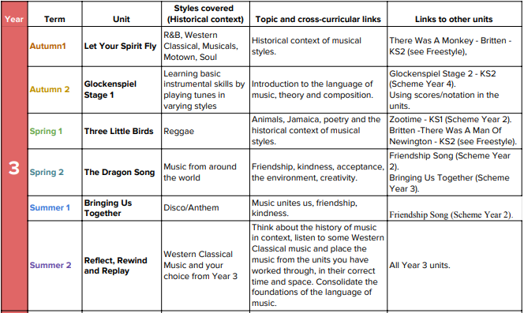

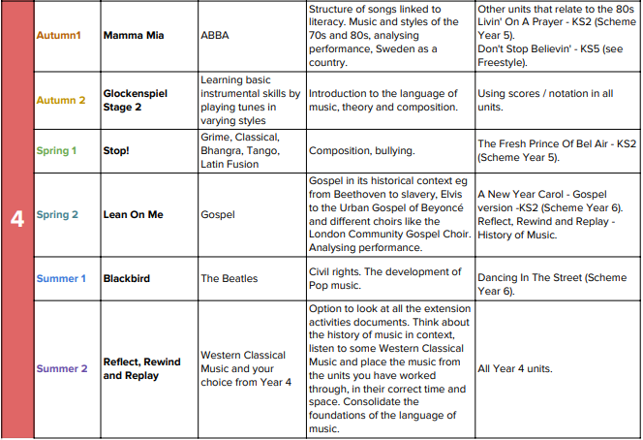

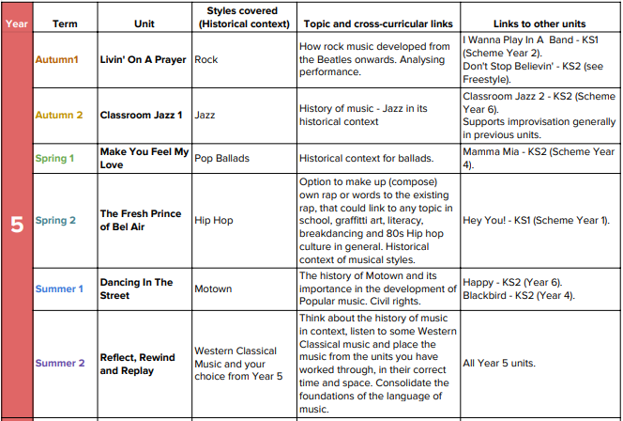

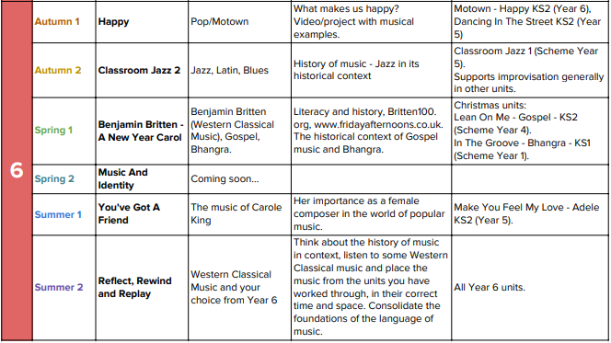

**Assessment**

Formative assessment is use to monitor student learning and provide ongoing feedback to the children during the unit of work. At the end of a unit, summative assessment is used to evaluate learning by completing the assessment spreadsheet based on the progression of skills. Recordings and videos of children’s work are kept on Sharepoint in the Music folder. Children’s progress is reported to parents annually in reports.

# Monitoring and review

The coordination and planning of the Music curriculum are the responsibility of the subject leader. The subject leader is responsible for evaluating the strengths and weaknesses in Music and indicating areas for further improvement on the following action plan. The subject leader will also monitor to ensure that the Programmes of Study are being effectively taught and match the needs and abilities of the children

# Inclusion and differentiation

At our school, we teach Music to all children, whatever their ability and individual needs. Music forms part of the school curriculum policy to provide a broad and balanced education to all children. Through our Music teaching, we provide learning opportunities that enable all children to make good progress. We strive hard to meet the needs of those children with special educational needs, those with disabilities, those with special gifts and talents, and those learning English as an additional language, and we take all reasonable steps to achieve this.

# Resources

There are sufficient resources for all Music teaching units in the school. We keep these resources in a central store, where there are class sets of percussion instruments, ukuleles and recorders. Teachers can access music for their classes via a school Spotify account, and children have access to music software such as Garageband.

**Signed by Music Subject Leader: Mr C Bottle**

**Date: 24th April 2025**

**Review date: April 2027**